The current peer to peer lending structure, represented by Bitfinex exchanger, present several inefficiencies that have already been illustrated.

The motivations, could be explained as follow:

* Restrictions on fund usage: Bitfinex allow the user to borrow funds at the condition that the entire sum borrowed is invested in the market with leverage.   
  Given a situation where USD rate is 0.05% and GBP rate is 0.2%, a speculator could borrow USD at 0.05% (and the rate for USD marginally increases), exchange USD for GBP, and lend GBP for 0.2% (and the rate for GBP marginally decreases). The speculator would continue this practice until the expected return from the transaction is lower than the currency risk. By assuming the average speculator is indifferent at holding USD or GBP, then there won’t be free lunch in the market and the two rates will be the same.   
  With this restriction on fund usage this operation is not possible, causing big differences in lending rates between currencies, based on offer and demand.
* Expensive trading between currency pairs

Given a situation where USD rate is 0.05% and GBP rate is 0.2%, a speculator that holds USD could decide to exchange USD for GBP, lend it at 0.2% and at the end of the loan, get back to USD. This transaction would have a cost of few basis points in a traditional broker, but at Bitfinex (and all the other analyzed crypto exchangers) it is not possible to exchange currencies.  
To take advantage of the rate disparity, a trader should buy BTC (0.2% commission), sell BTC for GBP (0.2% commission), lend GBP (0.2% return), buy BTC (0.2% commission) and sell it for USD (0.2% commission).   
This clearly gives a negative payout for a loan of one day, and in general disincentivize speculators to take advantage of spike in rates in other currencies.

* Opaque structure

It is not immediate for a margin trader to understand the conditions at which he undertakes a loan. In this way, several traders are opening positions without understanding of the borrowing rate, that could potentially erode profits significantly.

* Lending funds not guaranteed

Leaving the funding of the margin traders completely peer to peer could cause bubbles, in the moment that it is possible to margin buy a cryptocurrency but it is not possible to margin sell it (because no one is lending that cryptocurrency).  
A margin seller post the order in the orderbook, but when someone tries to buy from the order, (assuming a market order) the order disappear because there is no lender available to fund the order, and the order will be executed at the next available price (not posted by a margin seller).  
The impossibility to short sale and the misalignment created by the fact that there are margin buys and not margin sales pushes the prices up, liquidating the short positions already opened.  
A reserve provided by the exchanger for each shortable currency, allowing short sales even in distressed moments, would avoid such occurrences.

A concrete example of impossibility of short sales happened in January 2020 when BSV, when Craig Wright, continues to claim that he is Satoshi Nakomoto (Blockchain.news, 2020 - “Is the Price of Bitcoin Satoshi Vision (BSV) Driven by Fake News?”).

During the upside starting from 300$ there wasn’t the possibility to short sell. Liquidations occurred two times: the first one when the price was 380$ and the second one at 440$.  
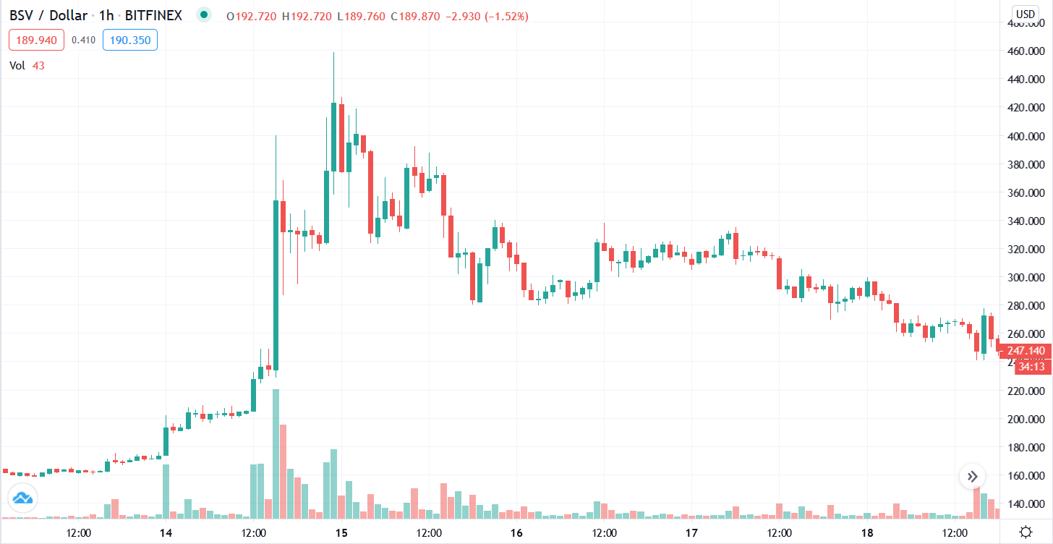

Part of these inefficiencies, as seen, are overcome by Binance by applying a centralized lending system. However an efficient solution would be to build a decentralized exchanger with low costs of smart contract executions (Ethereum at the current condition, wouldn’t be enough), and allow the above mentioned operations.